Description on how to download historical Hang Seng Index futures from HKEX.com.hk:

Among other data, historical Hang Seng Index Futures are available at http://www.hkex.com.hk. Manually done, the daily market reports can be individually accessed by selecting the date on the calendar page http://www.hkex.com.hk/eng/stat/dmstat/dayrpt/dmrcalendar.asp, and picking the “Hang Seng Index Futures”.

For example, following the above-mentioned steps for 22 June 2012, futures contract data appear at this URL:
http://www.hkex.com.hk/eng/stat/dmstat/dayrpt/hsif120622.htm

With HSQuote Plus and a format file, hkex_D4.fmt, such data can be downloaded automatically and stored in MetaStock data files. Furthermore, individual contract symbols need not be manually entered, and downloading for one whole period can be down at one go.

Set-up:

- Copy the following line and append to your existing “mywebserver.txt”, or simply substitute it the attached “mywebserver.txt”.

HangSeng Futures,http://www.hkex.com.hk/eng/stat/dmstat/dayrpt/hsifyy2ymm1mdddd.htm,D4,hkex_D4.fmt

- Copy the “hkex_D4.fmt” file to the “fmt” subfolder in the Data File Location shown on the Preference screen.
- Run HSQuote Plus and set up the screen as shown.

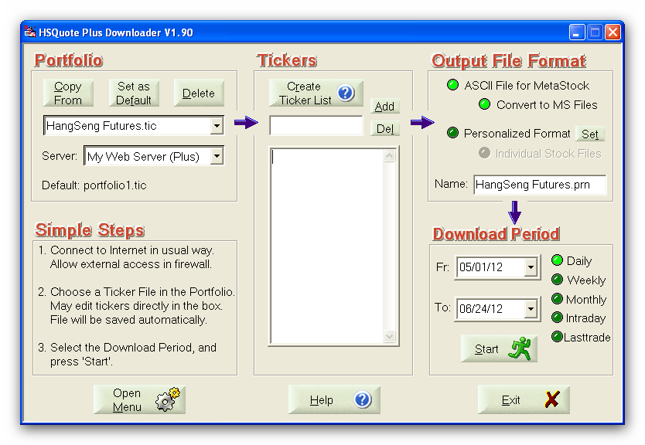

Historical Daily Data Download:

Just indicate the Download Period, and click on the ‘Start’ button. Note that HKEX does not provide more than 2 months of data.

