Description on how to download historical daily data from Google Finance:

There are several URL formats to get historical data from Google Finance. Three formats are given here.

Format 1 (one page with about 250 data points from today):

This format file fetches only the first page of data from URL:
http://finance.google.com/finance/historical?q=SHA:600005&histperiod=daily&start=0&num=300

This always gets about 250 daily data or so from today regardless of the Fr and To dates. It’s good for MetaStock data download format.

Set-up:

- Copy the following line and append to your existing “mywebserver.txt”, or simply substitute it the attached “mywebserver.txt”.

Google_D_XXXX,http://finance.google.com/finance/historical?q=XXXX:SSSS&start=0&num=300&histperiod=daily,D1,Google_D1.fmt

- Copy the “Google_D1.fmt” file to the “fmt” subfolder.
- Run HSQuote Plus and set up the screen as shown.

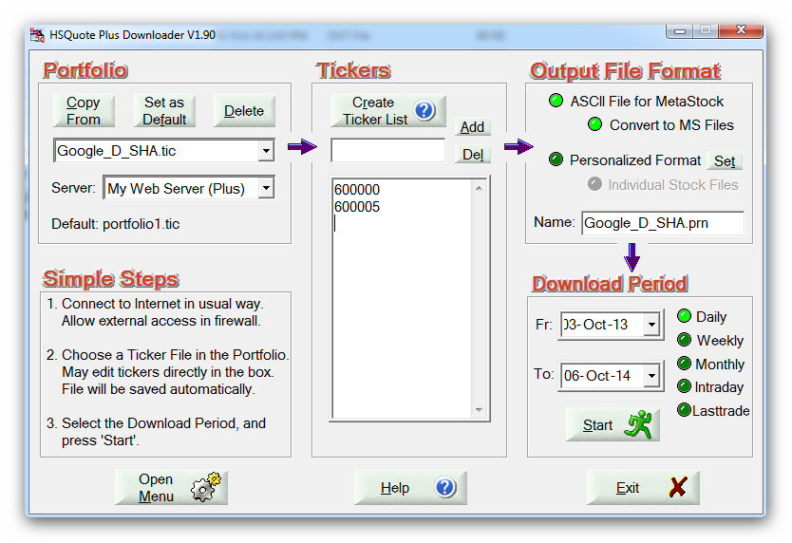
Format 2 (longer historical data on multiple URL pages):

This format can get older historical data with dates indicated by Fr and To date (but due to some constraint, about one page of data near the Fr date cannot be captured. Just indicate an older date for Fr date.)

http://finance.google.com/finance/historical?q=TYO:9020&startdate=Jan+1%2C+2006&enddate=Jan+10%2C+2008&start=0&num=100

Set-up:

- Copy the following line and append to your existing “mywebserver.txt”, or simply substitute it the attached “mywebserver.txt”.

Google_hist_XXXX,http://finance.google.com/finance/historical?q=XXXX:SSSS&startdate=mm3m+dddd%2C+yy4y&enddate=MM3M+DDDD%2C+YY4Y&start=NNNN00&num=100&histperiod=daily,D2,Google_hist_D2.fmt

- Copy the “Google_hist_D2.fmt” file to the “fmt” subfolder.
- Run HSQuote Plus and set up the screen as shown.

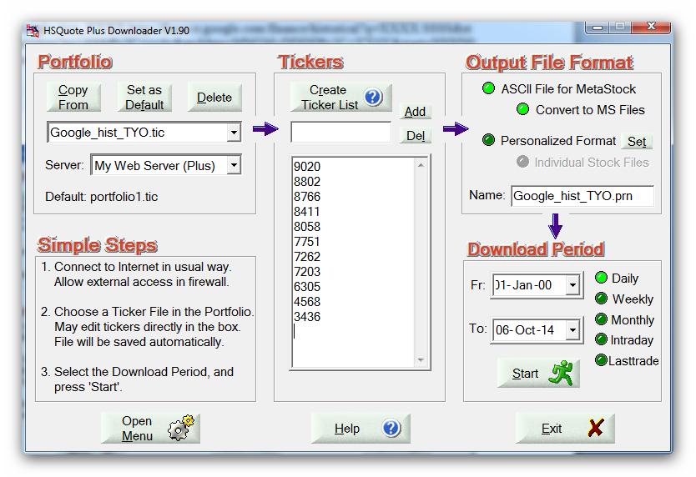

Format 3 (longer historical data on one csv spreadsheet):

Google Finance provides comma-separated CSV spreadsheets for stocks on some US stock exchanges, such as NYSE. This format file uses the Table method to download data from this spreadsheet. The advantage is to get long historical data. Since the date range captured is exact, it may be better for Personalized Text Format download. The URL is:

http://finance.google.com/finance/historical?q=NYSE:HPQ&startdate=Jan+1%2C+2005&enddate=Jan+1%2C+2008&histperiod=daily&output=csv

Set-up:

- Copy the following line and append to your existing “mywebserver.txt”, or simply substitute it the attached “mywebserver.txt”.

Google_D_XXXX,http://finance.google.com/finance/historical?q=XXXX:SSSS&startdate=mm3m+dddd%2C+yy4y&enddate=MM3M+DDDD%2C+YY4Y&histperiod=daily&output=csv,D12,Google_D12.fmt

- Copy the “Google_D12.fmt” file to the “fmt” subfolder.
- Run HSQuote Plus and set up the screen as shown.

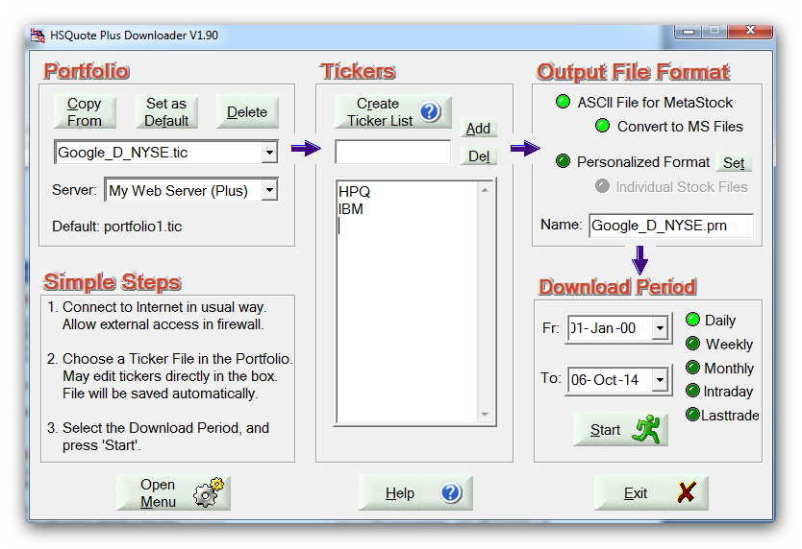

Exchanges with data on Google:

Exchange | Delay
American Stock Exchange (AMEX) | 20 min
Australian Stock Exchange (ASX) | 20 min
Bank of Canada | 15 min
Bombay Stock Exchange (BOM) | 10 min
Canadian Venture Exchange (CVE) | 15 min
Commodity Systems, Inc. | Indices Historical Data
Dow Jones Indices | Real-time
Euronext: Amsterdam (AMS) | 15 min
Euronext: Brussels (EBR) | 15 min
Euronext: Lisbon (ELI) | 15 min
Euronext: Paris (EPA) | 15 min
Frankfurt Stock Exchange | 15 min
FTSE Indices | 15 min
Hang Seng Indices | 15 min
Hong Kong Stock Exchange (HKG) | 15 min
London Stock Exchange (LON) | 20 min
Milan Stock Exchange (BIT) | 20 min
Morningstar (Mutual Fund) | End-of-Day
NASDAQ Indices | Real-time
NASDAQ Stock Exchange (NASDAQ) | Real-time*
National Stock Exchange of India (NSE) | Real-time
New York Stock Exchange (NYSE) | Real-time*
New York Stock Exchange Indices | Real-time
New Zealand Stock Exchange (NZE) | 20 min
Nikkei Indices | 20 min
Options Pricing and Reporting Authority (OPRA) | 15 min
S&P Indices | Real-time
Shanghai Stock Exchange (SHA) | Real-time
Shenzhen Stock Exchange (SHE) | Real-time
Taiwan Stock Exchange (TPE) | 20 min
Telekurs | End-of-Day
Tokyo Stock Exchange (TYO) | 20 min
Toronto Stock Exchange (TSE) | 15 min
XETRA German Electronic Exchange | 15 min

